**Capstone Project – The Battle of London Neighbourhoods**

**By**

**Sin Wee Lee**

**Version 1: 11/03/2019**

**Table of Contents**

|  |  |  |
| --- | --- | --- |
|  |  | **Page** |
| **1** | **Introduction** | **3** |
| **2** | **Data Descriptions** | **5** |
| **3** | **Methodology** |  |
| **4** | **Implementation and Results** |  |
| **5** | **Discussions** |  |
| **6** | **Conclusions and Future Work** |  |
| **7** | **Reference** |  |

# Introduction

London, capital and one of the largest city of both England and the United Kingdom, voted most attractive city to work for overseas worker in a global survey of 3666,000 people, beating New York, Berlin and Barcelona to take the top spot in 2018 (Total Jobs and Boston Consulting Group).

However, with Brexit fast approaching, there are not clear forecasts on the impacts of Brexit on the social, economic and the development of the city. To anticipate the impacts, local authorities (local government) are looking at ways to reduce cost and have more targeted development at borough level.

Although London as a whole has been booming for the last decade, the segregation of wealth across London are still visible since the 80s. Thus, it will be interesting to see how the social, economic impacts influence the facilities, venues and amenities available in the boroughs.

In order for the stakeholders, the local authorities and the business chamber of commerce to understand the social and economic impacts based on the facilities and amenities of certain borough and how this insights can provide targeting local and business development for London boroughs.

This project aims to address this by carried out a comparative studies on the facilities and amenities between the two boroughs with the highest income rate and the lowest in London.

In London, there are 32 London boroughs and the City of London. Among them, Tower Hamlet have the highest poverty and Bromley has the lowest. Although the data are from 2013/14, the stats remained at the same level.

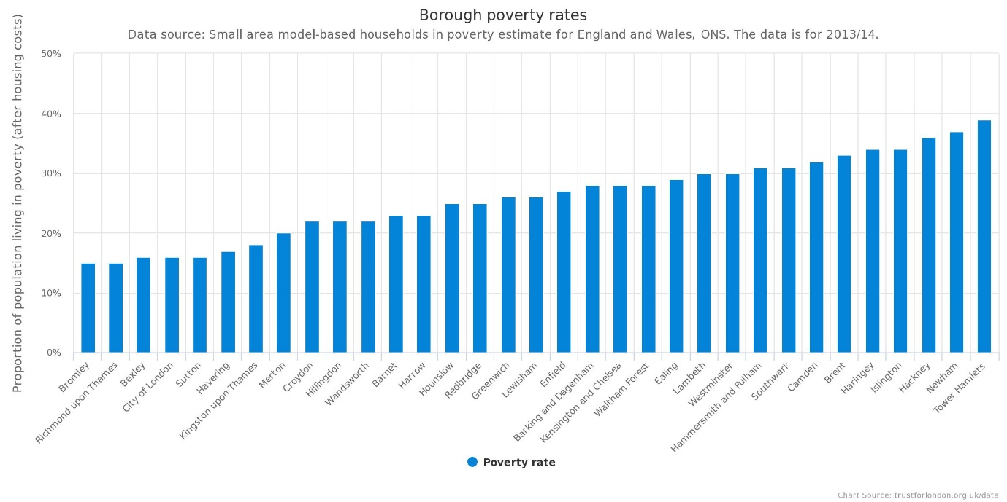

**Notes:**

London’s Poverty profile is created by charitable funder, Trust for London, and the independent think tank, New Policy Institute.

**Questions to answer:**

1. What types of facilities (venues) and amenities are available in the area with different poverty line?
2. How venues changing based on the spending power?
3. What are the distinctive venues that represent in these boroughs
4. Suggestions and recommendations of development in these areas.

By answering the above questions, the findings can be used for the targeting development for the rest of the London Boroughs so that unnecessary development can be avoided and overall budget can be sustained.

# Data Descriptions

The data folder for this project will consists the following data set:

**TH_neighbourhoods.csv**

Number of Instances: 15

Sources: <https://www.distancesto.com/coordinates/gb/>

Date accessed: 11/03/2019

This dataset consists of three attributes:

* *Neighbourhood:* the neighbourhood name in Tower Hamlet
* *latitude:* latitude of the neighbourhood
* *longitude:* longitude of the neighbourhood

Sample data: *first 7 instances of the dataset*

|  |  |  |
| --- | --- | --- |
| **neighbourhood** | **latitude** | **longitude** |
| **Bethnal Green** | 51.526962 | -0.06674 |
| **Blackwall and Cubitt Town** | 51.495182 | -0.009826 |
| **Bow East** | 51.528309 | -0.019482 |
| **Bow West** | 51.528309 | -0.019482 |
| **Canary Wharf** | 51.505219 | -0.0189 |
| **Island Gardens** | 51.487061 | -0.007988 |
| **Lansbury** | 51.513294 | -0.027155 |

**BROM_neighbourhoods.csv**

Number of Instances: 20

Sources: <https://www.distancesto.com/coordinates/gb/>

Date accessed: 11/03/2019

This dataset consists of three attributes:

* *Neighbourhood:* the neighbourhood name in Tower Hamlet
* *latitude:* latitude of the neighbourhood
* *longitude:* longitude of the neighbourhood

Sample data: *first 9 instances of the dataset*

|  |  |  |
| --- | --- | --- |
| **neighbourhood** | **latitude** | **longitude** |
| **Bickley** | 51.40174 | 0.043712 |
| **Biggin Hill** | 51.331959 | 0.029057 |
| **Bromley Common & Keston** | 51.375875 | 0.043819 |
| **Bromley Town** | 51.402805 | 0.014814 |
| **Chelsfield & Pratts Bottom** | 51.357943 | 0.127288 |
| **Chislehurst** | 51.411572 | 0.076955 |
| **Copers Cope** | 51.419348 | -0.031502 |
| **Cray Valley East** | 51.401639 | 0.020742 |
| **Crystal Palace** | 51.419366 | -0.071133 |

Based on the problem definition, factors that will influence the decision in this project will be:

* number and the type of venues and facilities available in the suurounding area of these boroughs
* the most frequent venues and facilties for each boroughs

To define the surrounding area of the borough, we will be using:

* London Boroughs poverty information from: <https://www.trustforlondon.org.uk/data/poverty-borough>. *Accessed: 11/03/2019*
* latitudes and longitudes of Tower Hamlet and Bromley obtained from: <https://www.distancesto.com/coordinates/gb/>. *Accessed: 11/03/2019*
* venues, type and locations in every borough will be obtained using Foursquare API

Further information of the boroughs can be found at:

* Bromley: <https://en.wikipedia.org/wiki/London_Borough_of_Bromley>
* Tower Hamlet: [**https://en.wikipedia.org/wiki/London_Borough_of_Tower_Hamlets**](https://en.wikipedia.org/wiki/London_Borough_of_Tower_Hamlets)